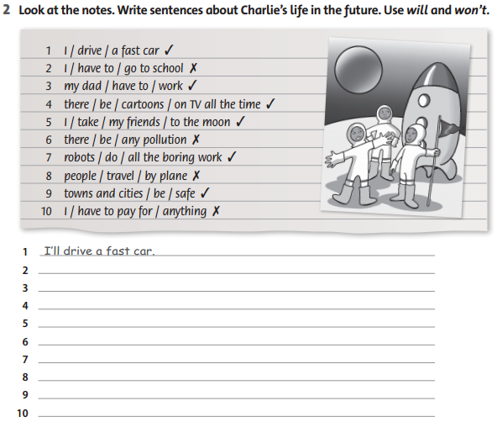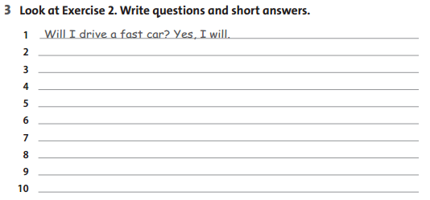

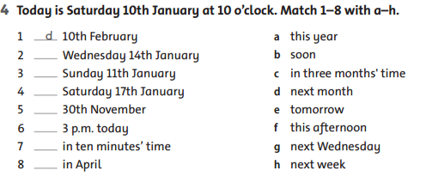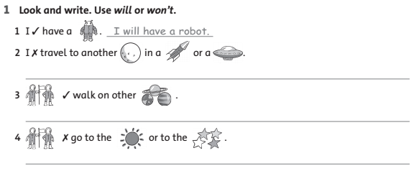

**2. Chọn au/aw:**

|  |  |  |  |  |
| --- | --- | --- | --- | --- |
| Description: C:\Users\Administrator\Pictures\1.PNG | Description: ../Pictures/2.PNG | Description: ../Pictures/3.PNG | Description: ../Pictures/4.PNG | Description: ../Pictures/5.PNG |
| _ _gust | p_ _ | jigs_ _ | s_ _se | str_ _ |

